**SE4050 – DL**

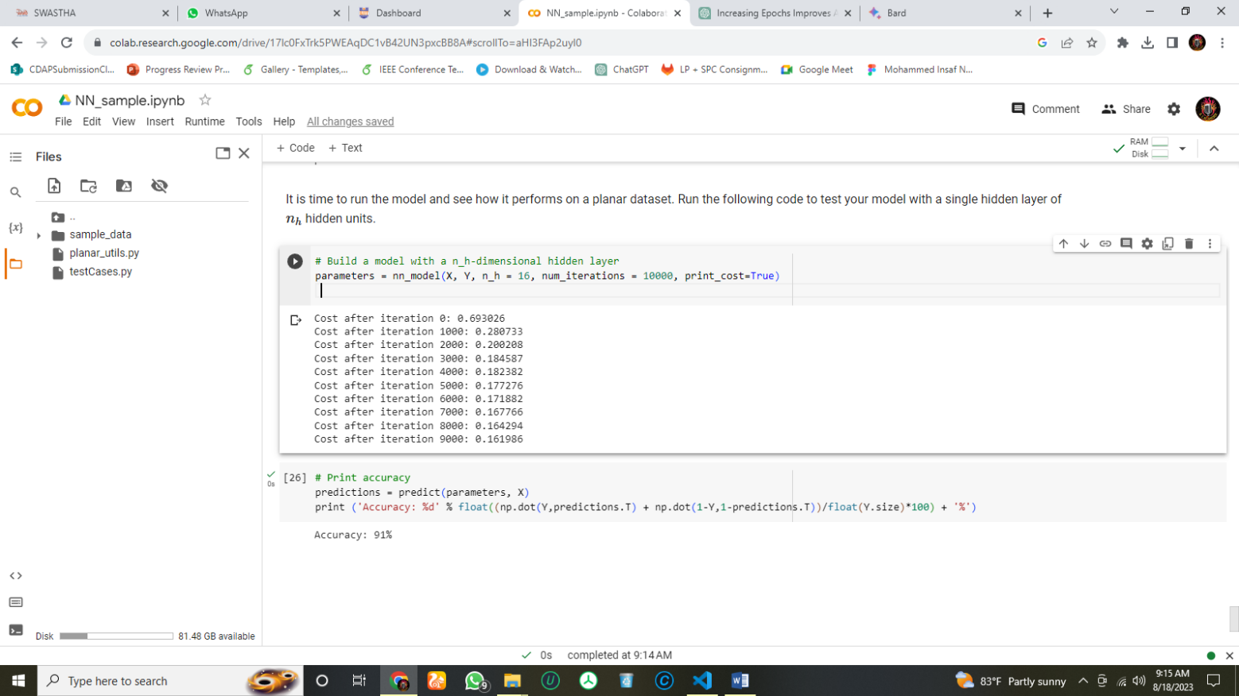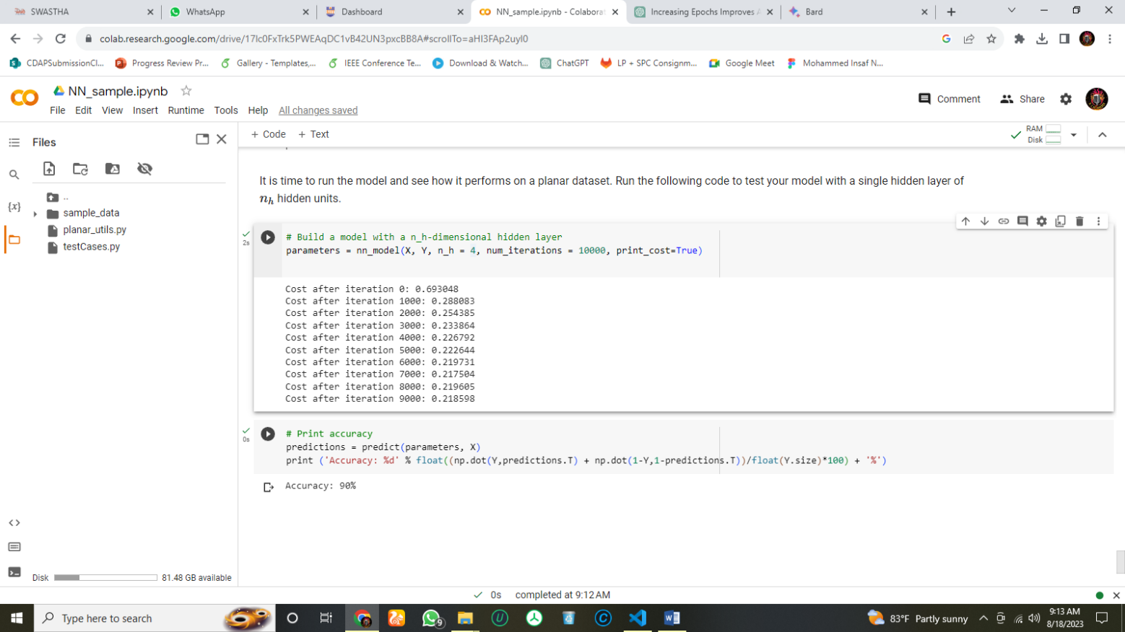**Lab 2**

Figure 1: Number of Hidden Units 08

Figure 2: Number of Hidden Units 04

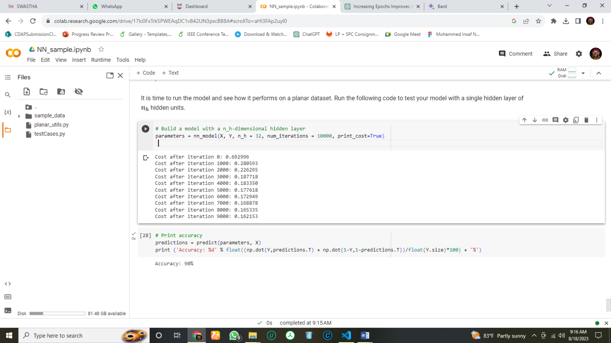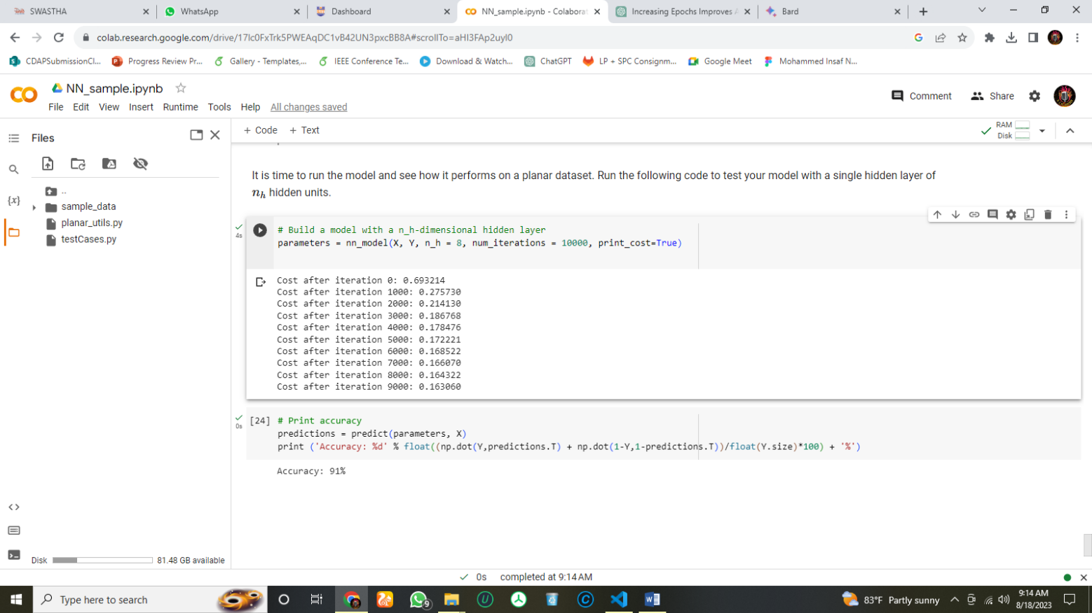

Figure 4: Number of Hidden Units 32

Figure 4: Number of Hidden Units 16

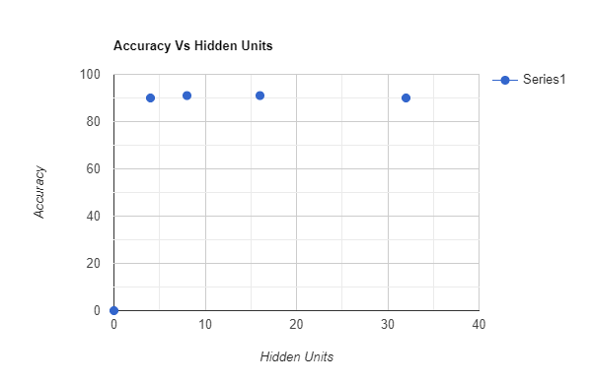1.

The number of hidden nodes in a neural network controls its capacity to learn and model complex relationships in the data. Each hidden node captures and processes different features or aspects of the input data.

**Benefits of increasing the number of hidden nodes**

A larger number of hidden nodes allows the network to capture finer details and intricate patterns in the data, which can lead to improved accuracy and better generalization. Complex data, such as images or intricate patterns, can be better represented with a larger number of hidden nodes.

**Challenges of increasing the number of hidden nodes**

With an excessive number of hidden nodes, the network might start memorizing the training data (overfitting) rather than learning generalizable patterns. This can lead to poor performance on unseen data. Larger networks are computationally more expensive and might require more data to prevent overfitting.

The optimal number of hidden nodes depends on the complexity of the data and the desired accuracy. A good starting point is to use a small number of hidden nodes and then increase the number until the desired accuracy is achieved. It is also important to monitor the network for overfitting and to adjust the number of hidden nodes accordingly.

2.

Hidden Nodes :-> 4 (Accuracy: 90%): relatively small number of hidden nodes, the network might not have enough capacity to capture all the nuances in the data. This can lead to under fitting, where the network struggles to learn the underlying patterns, resulting in suboptimal accuracy.

Hidden Nodes :-> 8 (Accuracy: 91%): By increasing the number of hidden nodes, the network's capacity to capture more intricate patterns improves. The additional complexity helps the network achieve better accuracy by fitting the training data more closely.

Hidden Nodes :-> 16 (Accuracy: 91%): Increasing the number of hidden nodes further enhances the network's capacity to learn from the data. At this point, the network is likely capturing a good balance between generalization and complexity, resulting in a continued improvement in accuracy.

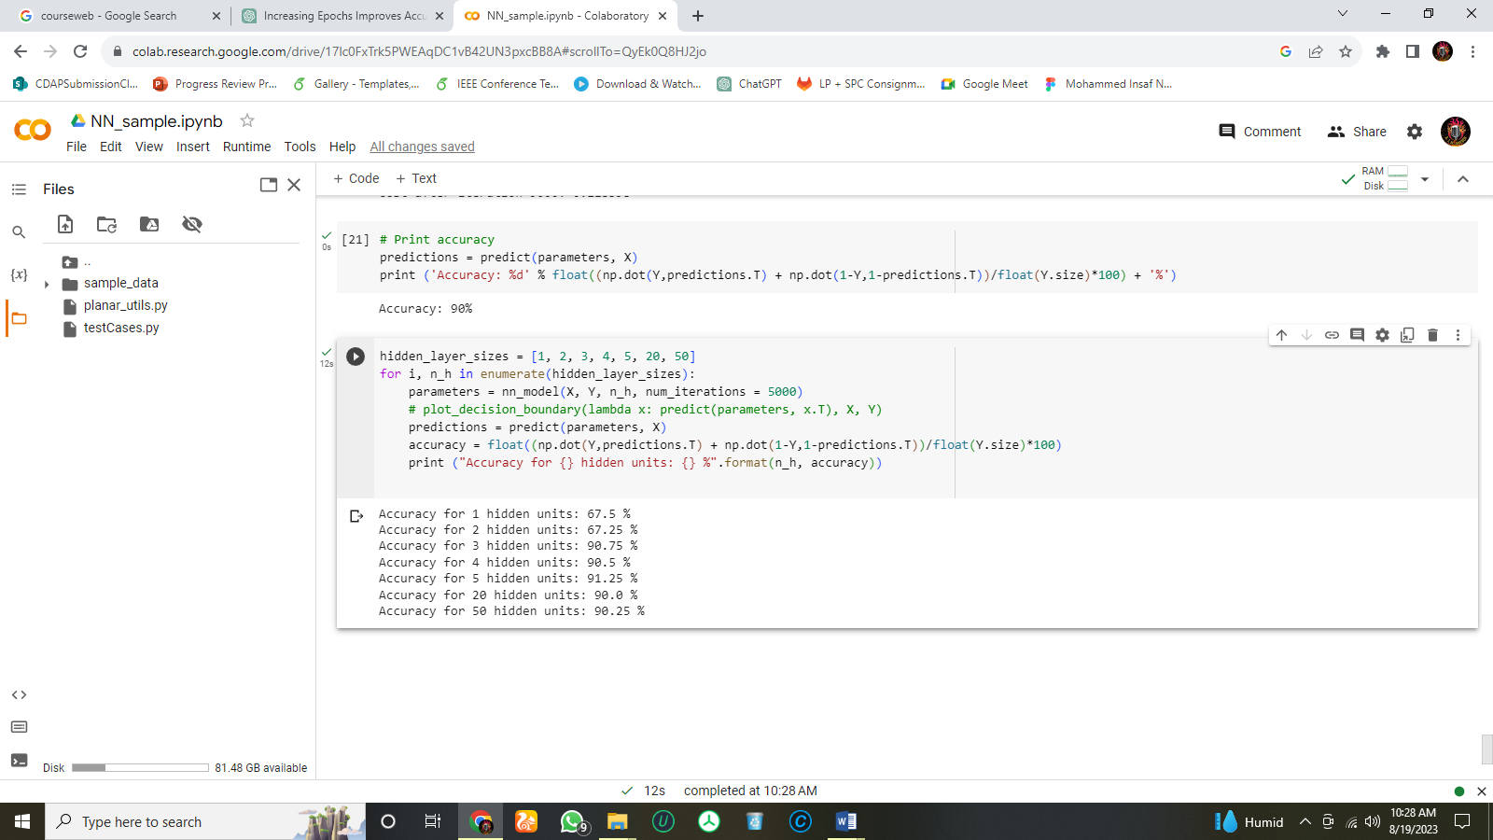Hidden Nodes :-> 32 (Accuracy: 90%): Especially working with smaller datasets and the network becomes overly complex, increasing the number of hidden nodes beyond a certain point might lead to overfitting. The network might start to memorize noise in the training data, causing a slight drop in accuracy on unseen data.